Clinical Interview Technique | Transcript | Strengths, Boundaries, and Access
Set-up
Technique: I set up the norms of the clinical interview, where the student is the expert, and I am learning from her. | 00:01 K: Okay, so we are doing something a little bit different today than we have been doing before. So some of the things that we've been doing before is I've been asking you to solve problems in certain ways, and today we're doing something different where I just want to get as much as I can, a sense of how it is you're thinking about mathematics so that I can sort of remember and think about this and think about what we might plan for next year in terms of you going into fourth grade and stuff. So your job right now is to just do anything you can to use words or pictures or stuff to show me how you're thinking about mathematics. Okay? And I don't care so much about right answers or wrong answers, I just care how you're thinking about it. Okay? (student nods) So you're the expert. (student nods) I'm just learning from you. Okay. And we have pens that you can use to draw color. Are you warm enough? (student nods) Okay, Great. Good. So how would you say math is going this year?
 | 01:03 E: Good.
 | 01:04 K: Yeah. Is there anything in math that feels like it makes sense and that's super easy or that you like doing?
 | 01:17 E: Not Really.
 | 01:17 K: Not really. Is there anything that you find super difficult?
 | 01:22 E: No.
 | 01:23 K: No? Okay. So it's just, okay. How do you feel when you're doing math? You have a big smile on your face. Is that a hard question to answer?
 | 01:37 E: Yeah.
Technique: I ask specifically about tools that are helpful. | 01:38 K: Okay. Let's move on to a different kind of question. Is there anything, any tools that you like using when you're doing math that help it make more sense?
 | 01:48 E: (Shakes head no)
Counting on forward and backwards
Technique: I start with a question that I think will be easy and put her at ease. | 01:48 K: No, not really. Okay. So one of the things that we have done some of, and I am just going to ask you a whole range of different kinds of questions. So these are going to be things different from what we've been working on, but is it easy for you or hard for you to count from a number that I randomly pick?
 | 02:14 E: Easy, but kind of hard.
Technique: I do not presume that she will be able to do this task. | 02:16 K: Easy, but kind of hard. So what would it sound like if you were to count up starting at something like 47? Would you be able to do that?
 | 02:23 E: From ones?
Technique: I answer questions to clarify the task itself. | 02:26 K: From, yeah. Counting by ones.
 | 02:29 E: Wait, from 47?
 | 02:30 K: From 47, Yeah.
 | 02:31 E: 48, 49, 50, 51, 52, 53, 54, 55, 56, 57, 58, 59, 60, 61. | Strength: Counting on from 47.
Technique: I stop her after a couple decade transitions | 02:41 K: So does that feel okay?
 | 02:42 E: Yeah.
 | 02:43 K: What about counting backwards?
 | 02:45 E: From 47?
 | 02:46 K: What about from 63?
 | 02:50 E: Um, easy!
 | 02:51 K: Okay, let me hear it.
 | 02:52 E: 62, 61, (omits 60) 59 actually 58, 57, 56, (omits 55), 54, 53, 52, 51, 50, 49, 48, 47... | Boundary: She is able to count backwards but omits 60 and 55.
Technique: I praise the effort of counting, even though she missed numbers, asking her how she is figuring out next number. | 03:16 K: Great job. That seems like it's a little bit harder, right? How are you figuring out what number goes next?
 | 03:24 E: I am thinking about numbers counting down from 16 but harder. Like a harder 16, like 61. I switched the numbers over, but it still feels like I'm counting down from 16.
 | 03:42 K: Okay, so is counting down from 16 okay and easy or is that still pretty challenging?
Technique: At this decision point, I decide to move on from counting backwards to other topics. | 03:47 E: It's kind of challenging.
Skip Counting (by 2s, 10s, 5s)
 | 03:51 K: Okay. So it's kind of challenging. One of the things I think you've been doing some skip counting, right?
 | 03:57 E: Yeah.
 | 03:57 K: What numbers feel okay for you to skip count by?
 | 04:00 E: Probably twos, um 10s. No, not tens.
 | 04:09 K: Okay. Not tens. Can you show me how you skip count by twos?
 | 04:15 E: 2, 4, 6, 8, 10, 12, 14, 16, 18, 20... (pause and restates) 20, 22, 24, 26, 28, 30, 32. | Strength: She can skip count by 2s.
Technique: I stop her after a couple decade transitions | 04:31 K: Do you think you could just keep going?
 | 04:33 E: Yeah.
 | 04:33 K: That's Awesome! How high do you think you could go?
 | 04:37 E: I got to 100.
 | 04:39 K: You've gotten to 100 before? That's amazing!! So what about counting by tens?
 | 04:48 E: 10, 20, 30, 40, 50, 60, 70, 80, 90, 100. | Strength: She can skip count by 10s to 100.
Technique: I extend this question to see if she is able to make the transition past 100, because in previous data she had switched to counting by 1s after 100. | 04:55 K: Do you think you could keep going even past 100?
 | 04:57 E: 110, 120, 130, 140, 150, 160, 170, 180, 190, 200? | Strength: She can skip count by 10s to 200.
 | 05:12 K: How high do you think you could go? Is there a limit?
 | 05:16 E: Probably 700.
 | 05:18 K: 700 might be the limit? That's amazing. What about fives? Skip, counting by 5s...
 | 05:24 E: 5, 10, 15, 20, 25, 30, 35, 40, (omits 45, 50) 55, six--fifty, 65, 70, 75, 80, 85, 90. | Boundary: She is able to skip count by 5s, but omits 45, and 50backwards but omits 60 and 55.
 | 05:35 K: How do you know the next number that you're supposed to say when you're skip counting?
Technique: When Evelyn says she doesn't have a way of explaining how she figured out the next number, I move on. | 05:40 E: I don't know.
Decomposing 10
Technique: I praise effort, rather than specific correct answer. | 05:40 K: You don't know? Okay. That was so amazing! You did so much great counting! What if we were to think about our game that we have sometimes done where we have (gets base 10 blocks)...
 | 05:54 E: 10 ones.
 | 05:54 K: (counting out base 10 blocks) 2, 4, 6, 8, 10. So we have 10 things there.
 | 06:01 E: And then we get a cup.
 | 06:03 K: We get a cup, and then what do we do?
 | 06:09 E: (picks up blocks and puts them in the cup)
 | 06:09 K: Do we hide some of those? Okay. What if we have zero? And how many is under the cup?
 | 06:17 E: 10 (laughs)
 | 06:18 K: Zero and 10. Okay, great. You looked at me like that was a ridiculous one. What about four outside of the cup? (puts 6 under cup)
 | 06:23 E: Then there would be five. | Boundary: 4 and 6 = 10 not automatic (she thought 4 and 5 = 10), but she self corrects, when using fingers.
 | 06:25 K: There'd be five?
 | 06:25 E: No, Five.
Technique: I ask how she figured this out, and in subsequent problems she often shows me how she figured it out without this prompt. | 06:30 K: How are you figuring out what's under the cup?
 | 06:33 E: Because if you have four out (holds up 4 fingers) and then if you have 10 (looking at hands)... then no, it would be six.
 | 06:41 K: Okay, so it would be six?
 | 06:43 E: There would be six under here? Because, yeah, because you have these (hold up 4 fingers) this you have 4, 5, 6, 7, 8, 9, 10 (as she is counting up the remaining fingers).
 | 06:57 K: Beautiful. (hides 8 under cup) E, what about 2?,
 | 07:06 E: (holds up 2 fingers) 2, 4 (holds up 3rd finger). No, (puts up 2 fingers again) 2, (counts up with fingers) 3, 4, 5. (counting the newly raised fingers) 1, 2, 3, (counting the fingers of the other hand) 4, 5, 6, 7, 8. Eight. | Boundary: 2 and 8 = 10 not automatic, but can be determined with fingers.
 | 07:27 K: Awesome.
 | 07:28 E: I use my hands.
 | 07:29 K: And so is it helpful to use your hands to figure these out?
 | 07:31 E: Yes.
 | 07:31 K: Okay.
 | 07:32 E: I usually use my hands for most of my questions? I don't really use the 10 blocks. | Access: Evelyn prefers her fingers to solve problems over blocks
 | 07:37 K: Okay, so you're using your fingers for most of your questions. That's really helpful to know. What if we had five outside (puts 5 blocks under cup)
 | 07:42 E: Then there would be five in here.
 | 07:44 K: Okay. It just seemed like.
 | 07:44 E: So five plus five is 10. | Strength: Fluency with doubles, 5 and 5 = 10
 | 07:46 K: Okay. It seems like you didn't use your hands that much that time. Were you just thinking of your hands? | Strength: Fluency with doubles, 5 and 5 = 10
 | 07:52 E: No, because I learned this question when I was in first grade. | Strength: Fluency with doubles, 5 and 5 = 10
 | 07:57 K: Okay. | Strength: Fluency with doubles, 5 and 5 = 10
 | 07:58 E: Well basically kindergarten. | Strength: Fluency with doubles, 5 and 5 = 10
 | 08:00 K: What about, oops, I actually have to do some. What about we have one outside (hides 9 under cup)
 | 08:07 E: Then there would be nine over here. | Strength: Fluency with 1 and 9 = 10
 | 08:08 K: Nine. And do you have to use your fingers for that one? | Strength: Fluency with 1 and 9 = 10
 | 08:10 E: No. | Strength: Fluency with 1 and 9 = 10
 | 08:10 K: - or is that something you just know? | Strength: Fluency with 1 and 9 = 10
 | 08:12 E: Something I just know. | Strength: Fluency with 1 and 9 = 10
 | 08:13 K: Okay. What if we had eight on the outside? (hides 2 under the cup)
 | 08:18 E: Eight on the outside. Then there would be (pause 8 seconds, using fingers) two more. | Boundary: 8 and 2 = 10 not automatic, but she gets this correct using her fingers.
Technique: To avoid giving feedback on specific answers, I confirm by lifting up the cup to see if it matches. | 08:27 K: Okay, two more (lifts up cup). Great. I'm just trying to see that. We make sure we can see our little handies there (adjust laptop angle). What if we had three on the outside (hides 7 under cup)
 | 08:37 E: Then there would be (counting on fingers for 10 seconds). Three (recounts for 8 seconds). Seven. | Boundary: 7 and 3 = 10 not automatic (>20 sec), but she gets this correct using her fingers.
 | 08:59 K: (lifts up the cup to show 7 blocks) Seven. That's amazing. And one last one. What if we have six on the outside? (hides 4 blocks under cup)
 | 09:08 E: Six on the outside, then (pause, holds up hands) four more. Four. (K pulls cup away as E points to 4 blocks) | Boundary: 6 and 4 = 10 not automatic, but she gets this correct using her fingers.
 | 09:15 K: Beautiful! So it seems like, does it seem like it makes sense when you use your fingers? | Access: Fingers are a useful tool for her when decomposing 10.
 | 09:21 E: Yeah.
Problem: 8+6=
Technique: I remind the student that she can solve the problem using whatever tools she wants. And I present all problems verbally and in writing. | 09:22 K: To do those? Great. Awesome. Okay, so if you were to think of solving a problem like this (writes 8+6=), how would you think about solving that problem? You can use pens, you can use stuff, you can use your fingers, whatever way it works for you.  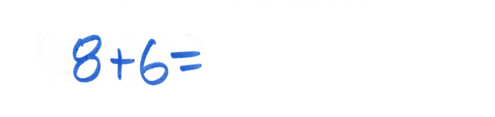
 | 09:44 E: I'm going to get the light pink (referring to markers).
 | 09:46 K: I love it.
 | 09:47 E: So one, (draws 1 line) two (draws second line), wait, hold on. (scribbles out the lines) (draws 8 dots) 1, 2, 3, 4, 5, 6, 7, 8. (draw 6 dots) 1, 2, 3, 4, 5, 6. (pause 17 seconds) It's either 13 or 14.  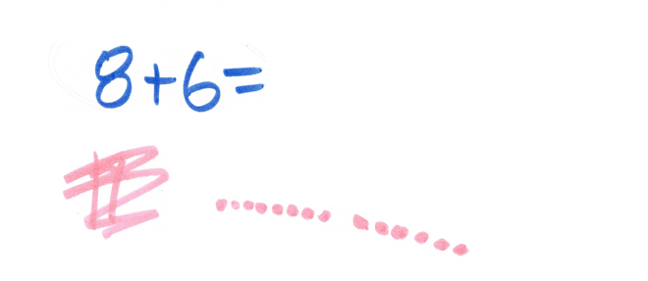 | Access: She starts solving this problem as if the 8 was 80, probably because she had been working on double digit subtraction problems by drawing base 10 representations. (misapplied procedure)  Strengths: Self-corrects, and creates a valid representation of 8+6 with dots.  Boundary: She is not sure if the answer is 13 or 14.
Technique: I ask her to explain her thinking | 10:30 K: It's 13 or 14. How are you thinking about that?
 | 10:32 E: It's 14. 14.
Technique: I continue to probe on thinking | 10:34 K: How are you thinking about that?
 | 10:35 E: Because, so you add the six up to another six, and that would be 12. And then if you add eight and eight, 16 and then you minus, you minus five. No, no. Usually how I do my questions is it's usually in the tens. Usually this number (circles problem) is too low. I don't do this low of a question. It's usually 80 plus (writes 80+). No, it's actually 80 minus like 60 (writes 80-60) if you wanted to do that kind of question (underlines 8+6=).  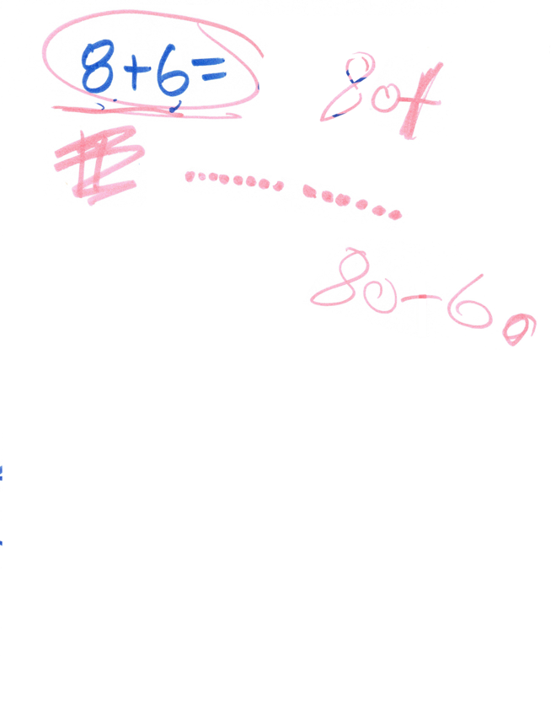 | Strengths: Fluency with doubles for 6 and 8.  Access: Misapplied procedure is confirmed as she refers back to the problems she has been solving recently, which are double digit subtraction problems.
Technique: I deviate from the protocol and follow Evelyn’s lead and ask about the question she posed 80-60= | 11:30 K: And so how would you do 80 minus 60?
 | 11:33 E: 80 minus 60. So it would basically just be like that (points with pen to the problem 8+6=) and then I would get 104? | Boundary/Access: Knows there is a relationship between the problems 8+6 and 80+60, but misapplies the procedure of adding the 0.
Technique: Without giving her any feedback on the correctness of her answer, I ask her to explain her incorrect answers in the same way as her correct answers. | 11:40 K: Okay. And how are you getting that?
 | 11:46 E: Because this low number is equals 14 (writes "14" after “8+6=”). So you would just add another one (writes 1), add another one to it (after the 1 writes 14), and then you'd get...  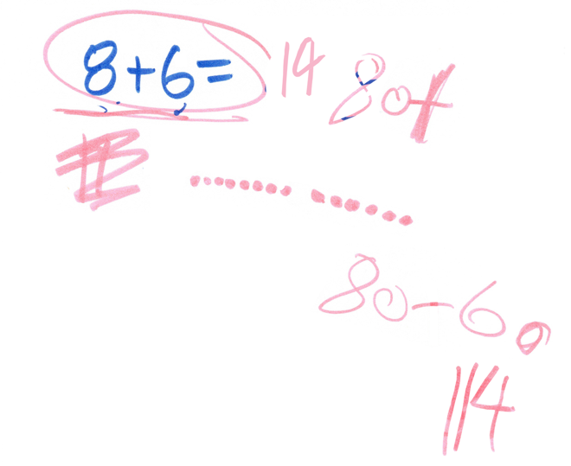 | Access: Misapplied procedure, she uses the answer of 8+6=14, but in this case adds a 1 rather than a 0, and adds it to the hundreds place.  Access: Notation: She solves the problem 80-60 as if it were 80+60.
 | 12:01 K: So it would get to be 114?
 | 12:03 E: Yeah.
 | 12:03 K: Okay. Can you...
 | 12:06 E: (interrupting) No, no! (scribbles out 114) (writes 80-60) So since it's minus, I got it wrong (writes =)  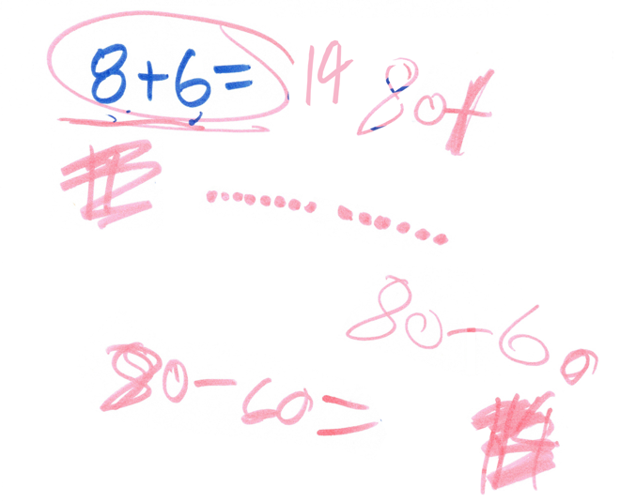  Because I was kind of thinking of it as plus (changes original problem from 80-60 to 80+60). It would be, so six minus eight. No, no, seven. (puts up thumb, then puts up pointer finger, then counts up 6 fingers and holds the fingers in front of her, then writes "200", underlines problem).  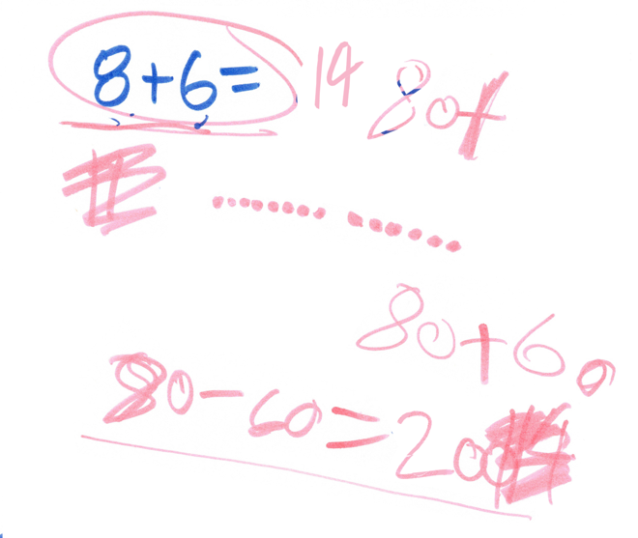 | Strength: Noticed that she was trying to solve 80+60 rather than 80-60.  Boundary: Able to figure out that 8-6 is 2 using her fingers.  Access: Quantity/Notation:, misapplies a procedure (adds 2 zeros rather than 1) and determines that 80-60=200, not attending to the impossibility of 200 as the answer.
 | 13:23 K: Okay. 200. Okay. You have done many different problems here in this one problem that I asked you. Can I ask some follow up questions on this?
 | 13:31 E: Yeah.
 | 13:32 K: Okay. So you figured out that you were doing 80 minus 60 there, right?
 | 13:38 E: Yeah.
Technique: I refer back to what I saw her doing with her hands to orient her to a follow up question. | 13:39 K: Okay. And can you tell me what you were doing on your hands to figure out what 80, minus 60 was?
 | 13:44 E: I was counting down like this.
Technique: I ask for specifics of what counting down sounds like. | 13:47 K: And what does it sound like in your head when you're counting down or what are you doing on your fingers?
 | 13:52 E: (trying to put pen cap on) Okay, that won't go? (gives up on trying to cap up pen)
 | 13:53 K: Yeah, you can just set it down.
 | 13:57 E: So I started from eight (writes 8) and went all the way down (draws line and arrow down). So eight, seven (writes 7) well, I don't start at eight (scribbles out 8), I start at 7, (as writes numbers) 6, 5, 4, 3, 2, 1. That'd be counting down (traces over the down arrow again). But if I went from one all the way to seven, well basically eight (rewrites 8 above). If you went from one going all the way up (draws up arrow) to eight, you would be counting down. But I don't count down. Most of the time I use either blocks, sometimes my fingers, and sometimes I think about it.  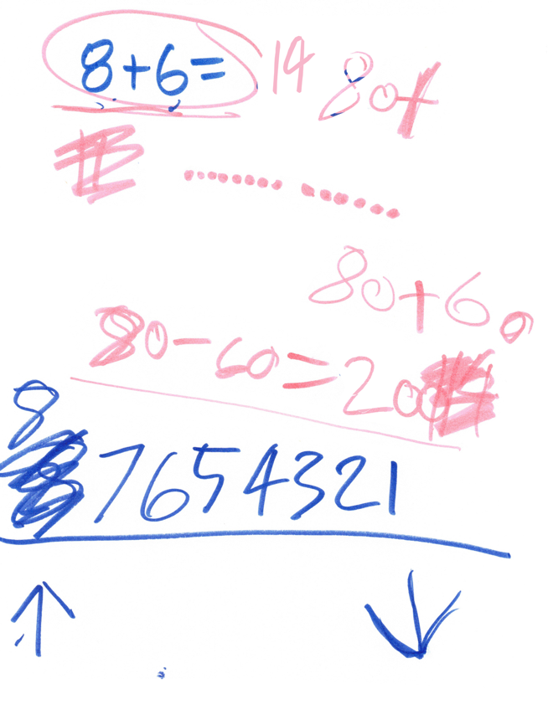 | Access - Quantity: I am interested in her representation of the sequence of numbers and the counting down or counting up being represented with arrows. This suggests she is focusing on counting a certain number down, and using what feels like procedural understanding about whether she starts at the 8 or the 7 when counting down. She identifies using fingers, blocks, and thinking about it as how she does this problem.
 | 14:57 K: And so how are you doing it just now? Were you thinking about 80 minus 60 as being like eight minus six? You could use eight minus six to figure it out?
 | 15:05 E: (nods)
Technique: This was a little bit like a counter suggestion, I tried to show a different counting strategy than I thought she was using, to see if she could say more about how she counted down. | 15:05 K: Okay. So you're using eight minus six (E writes 8-6), and you say you're counting down. Are you counting? I'm going to give you a bunch of different options and you tell me which one or a different one are you going? Eight (holding up 8 fingers) and then counting down six. So going (putting fingers down) 1, 2, 3, 4, 5?  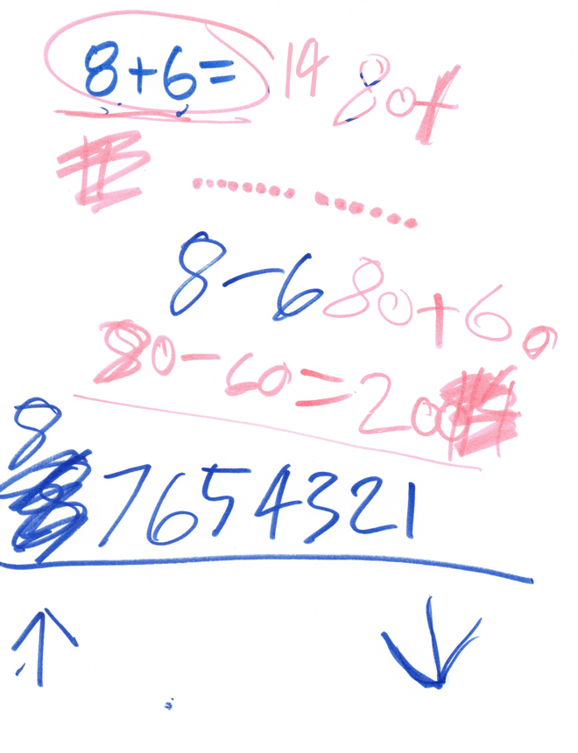
 | 15:23 E: Or No, no, I start at the bigger number.
 | 15:24 K: Oh, you start at the bigger number.
 | 15:26 E: So I go eight. No, I go (counting up on fingers as she counts down) 7, 6, 5, 4, 3, 2, 1. | Access – Quantity: To count down 6 from 8, she actually counts down 7.
Technique: I ask probing follow up question about how to know when she should stop counting down. | 15:35 K: Okay. And how do you know when to stop counting down?
action language for counting down. trial and error of counting down and then checking if she counted the right number down (again, she is gesturing and using 7 fingers, rather than 6). | 15:38 E: When... So you go down from, so you start at eight because count, sometimes I count from eight and I don't start at seven and I go downwards. And then once I get really low, I stop when I think and then I count my fingers to make sure it's not too much. | Access – Quantity: She is using lots of action language for counting down. Rather than starting at 8 and counting down 6, she starts counting down, and then uses her fingers to determine if she counted the right amount down. (she is gesturing and using 7 fingers, rather than 6). Procedural ambiguity around whether she should start at 7 or 8 when counting down. Therefore both the starting count number (8 or 7) and the amount to count down (6 or 7 fingers) are referenced here.
Technique: I mirror what she has done with her 7 fingers counting down and ask her to confirm that is how she solves the problem. | 16:02 K: Okay, so you're doing, so is it right that you're sort of going (holds up 8 fingers and counts them down as I say) 8, 7, 6, 5, 4, 3, 2, 1, and then you're seeing how many fingers you put down?
 | 16:16 E: (nods) And how many fingers are left up.
Technique: This is like a counter-suggestion because I have counted (7) the wrong number of fingers down, and I ask her to evaluate whether my answer is right or not. | 16:19 K: And so if I counted down to one, would I have counted the right amount down so I counted all of these fingers down (7 fingers down)? Would I have counted the right amount down? or the wrong amount down?
 | 16:32 E: Yeah (scribbles out 2 her answer of 80-60=200, and writes a 1)  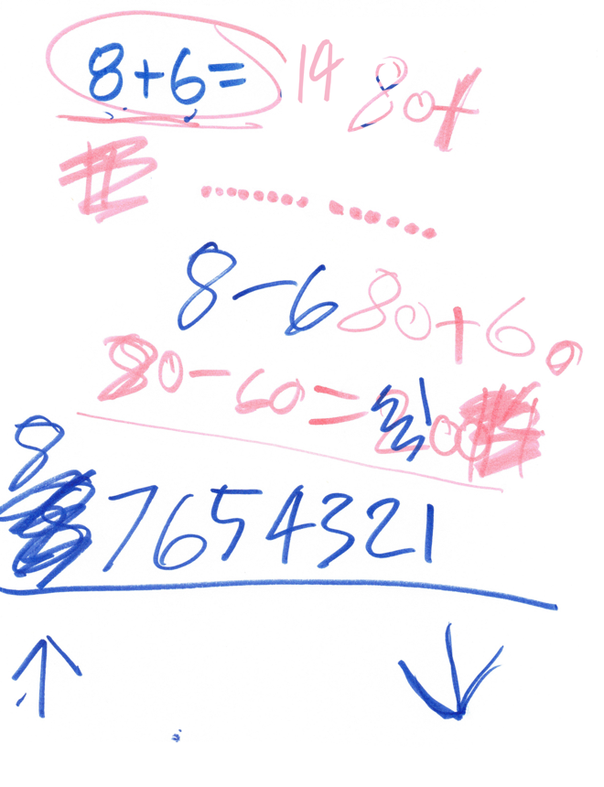 | Access – Quantity: She changes her answer so now her answer reads 80-60=100 because she thinks that 8-6=1.
 | 16:37 E: Yeah.
 | 16:37 K: Okay, so you think you might get to one there?
 | 16:39 E: Yeah, 100. Because if I went all the way down only to two, because when I counted I got to one, but I wrote two hundred. So...
Technique: I probe about the two zeros in the answer (80-60=100). | 16:59 K: How do you know about the zeros? How are you thinking about going from 80 minus 60 to knowing how many zeros to put in the answer?
 | 17:10 E: I don't know. | Access: Misapplied procedure of placing 2 zeros in the answer, perhaps related to multiplication. She is unable to explain why she put two zeros in the answer.
 | 17:10 K: Okay, so that's a tricky thing.
 | 17:13 E: Yeah.
Technique: I refer back to previous explanation to see if she can elaborate on her thinking for 8+6= using doubles. | 17:13 K: So can we go back to this problem (points to 8+6=14)? You said something super interesting. You said that eight and eight is 16 and six and six is 12, and then you figured out that the answer was 14. Are you using your doubles a lot when you have problems like this to figure it out? How did you figure out that it should be 14?
 | 17:39 E: Because if you change this number to a seven and you did seven, (writes 7+7 = 14) 14, but it's not seven, it's not seven (scribbles out 7+7=14), it's eight and six. It's not seven and six, it's eight and six. And you add the eight? No, you add the six to the eight, and then it's (counting up on fingers) 8, 9, 10, 11, 12, 13.  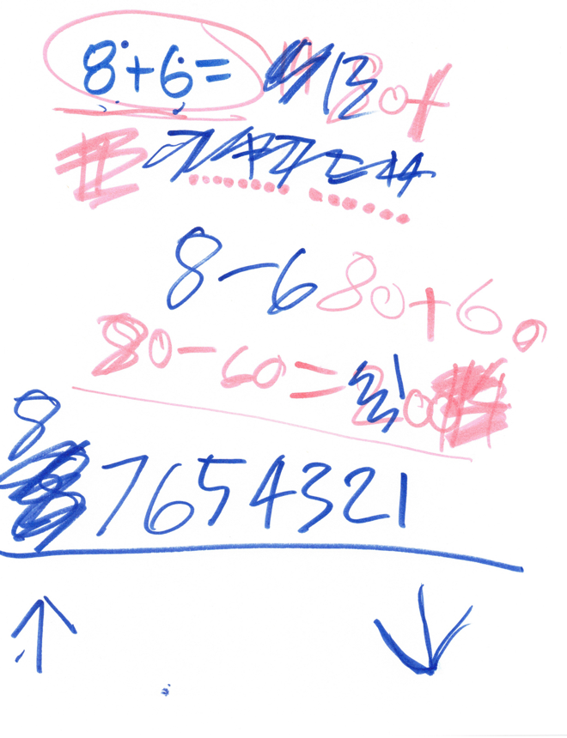 | Strength: doubles 7 and 7=14.  Access: Misapplied procedure – counting up 6 from 8, starting at 8 rather than 9.
 | 18:30 K: Okay, so you got then to 13 that time?
 | 18:33 E: Yeah.
 | 18:34 K: Okay.
 | 18:34 E: But the first time I got...
 | 18:36 K: To 14,
 | 18:37 E: Yeah.
Technique: Probing to see if she has a way of figuring out if it is 13 or 14. | 18:38 K: Okay. Yeah. And is there a way of figuring out which one is right? For sure?
 | 18:42 E: No.
 | 18:43 K: Okay. So
 | 18:45 E: Yeah, yeah.
Technique: Praising effort | 18:45 K: How would you figure out which one is right? I'm going to give us a new piece of paper. Just you've done so much. Amazing work on this.
 | 18:55 E: Say that. I have eight (writes "8+6 cook") cookie. | Strength: Creating a context (cookies) to make 8+6 meaningful.
 | 19:02 K: I love it.
 | 19:04 E: Cookies. I said cook, whatever. (scribbles out "cook")
 | 19:08 K: You got eight cookies?
 | 19:09 E: Yeah. (grabs foam squares and plate)
 | 19:10 K: Show me. Oh my gosh, this is great.
 | 19:30 E: 1, 2, 3, 4, 5... (counting out 8 foam pieces onto plate) Eight cookies.
 | 19:30 K: Beautiful.
 | 19:34 E: Eight cookies,
 | 19:35 K: Yum.
strength using a context and representing addition appropriately (combining two sets) | 19:35 E: And then I have six cookies (shakes out cookies onto plate) on another plate. 1, 2, 3, 4, 5, 6. (miscounts, and there are 7 not 6 cookies on second plate) Six cookies on this one, eight cookies on this plate. Let's say we added them together on one big plate (puts all foam pieces together), and then you added them all together and you wanted to make sure there was enough for all your friends. | Strengths: She uses a context (cookies) and represents cookies with manipulatives. She also represents addition appropriately (combining two sets)  Access – Quantity: She miscounts 6 blocks and ends up with 7.
 | 20:10 K: Okay.
 | 20:10 E: 1, 2, 3, 4, 5, 6, 7, 8, 9, 10, 11, 12. Okay. 13. (recounts 1 block, and misses counting 2 blocks) And you had 13 cookies and all for all your friends. | Access – Quantity: Multiple 1:1 correspondence counting errors, she misses 2 blocks, and she double counts 1, determining that 8+6=13, even though she has 15 blocks.
 | 20:24 K: We had 13 cookies in all.
 | 20:26 E: Yeah. (writes 13 in answer to 8+6=)
Technique: I praise effort, regardless of the correctness of the student's answer and process. | 20:27 K: Amazing. So to confirm the answer, would it be helpful to use something like this to sort of put it together? Okay, I'm going to add, that was such an amazing explanation, Evelyn. Look at all of the writing and work you did to help me understand how you were thinking about it. You are doing amazing! So I'm going to ask a different question, which if you saw the problem 13 minus seven, how would you think about solving that problem?
Problem: 13-7=
21:17 E: (draws 1 line and 3 dots, scribbles out the line) And you took away this for a 10. (counting as drawing 10 dots) 1, 2, 3, 4, 5, 6, 7, 9, 10. So I started off with three. So you have to get a lighter color. (switches marker)
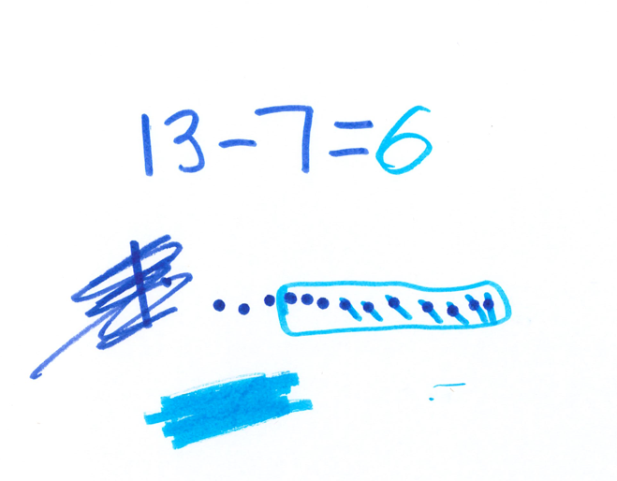
 | 21:33 K: Yeah, so you can see it.
 | 21:44 E: (draws a circle around the ten dots she added) So yeah. | Access: The prescriptive way she is drawing a box around the ten dots feels procedural and not grounded in meaning.
 | 21:49 K: So is this the answer?
 | 21:51 E: No, I just circled this number. I had the same color for both of them and I didn't want to think that we started off with 10 of these. Well, 13 actually, (scratchy voice) My voice. (tries to stick pen back in box) | Access: She seems to think that she did NOT have 13 to start with in this problem. Not thinking of the representation of one ten and 3 ones as a representation of 13.
 | 22:15 K: Yeah, sometimes it doesn't go back in as well (referring to pens)
 | 22:19 E: As it comes out (referring to pens). And I keep forgetting. And then you have these and then you take away 7. (as crossing out dots) 1, 2, 3, 4, 5, 6, 7. (writes 6) | Strengths: She is able to represent 13-7 using base 10 drawings.
 | 22:42 K: Awesome. So did it matter if you took them away from inside this blue rectangle or outside the blue rectangle?
 | 22:48 E: No.
 | 22:49 K: Okay, so you can do either one.
 | 22:51 E: Yeah.
Problem: 5x3=
22:51 K: Okay, awesome. Do you have any way of thinking about solving a problem, like five groups of three? (writes 5x3=)

 | 23:04 E: It's a little harder. I don't usually do times.
 | 23:09 K: Do you have a way of thinking about solving that kind of problem?
 | 23:16 E: Maybe using the blocks?
 | 23:19 K: Okay, how would that Look?
 | 23:24 E: I don't know. I don't really think...
 | 23:27 K: Okay, so this is sort of a harder kind of problem.
 | 23:29 E: Yeah.
Technique: I ask the problem in a different format to see if it's the calculation format or the idea of multiplication. | 23:31 K: Could I put a story problem around this and see if it helps? (shrugs) Okay. We'll see if it makes any more sense or if not, what if you have five bags of oranges and each bag has three oranges in it? Do you have a way of figuring out how many oranges you have total?
 | 23:58 E: Wait is times plus basically or minus? | Boundary: Although she knows it is the multiplication sign, she is not sure what multiplication means.
Technique: I do not answer the student’s question, and tell her that I’m interested in her thinking. | 24:02 K: I'm interested in how you're thinking about it. So is times plus basically or minus, do you think? There's different ways of thinking about it? I'm interested in how you're thinking about it. Does the story problem help or not help?
 | 24:21 E: Not help. | Boundary: The story problem is not helpful for her to be able to think through multiplicative context.
Problem: 38+26=
 | 24:22 K: Okay, great. Let's move on. You've used a bunch of different kinds of tools for different kinds of problems and this is super cool. So if you were to think about adding 38 plus 26 (writes 38+26=), you have a way of thinking about adding those together.
 | 24:51 E: Adding what? Oh!
 | 24:52 K: 38 and 26.
 | 25:18 E: (writes 3 lines and 8 dots) 1, 2, 3, 4, 5, 6, 7, 8. (crosses off two lines, and 6 dots). (writes 12 below, and then as answer).  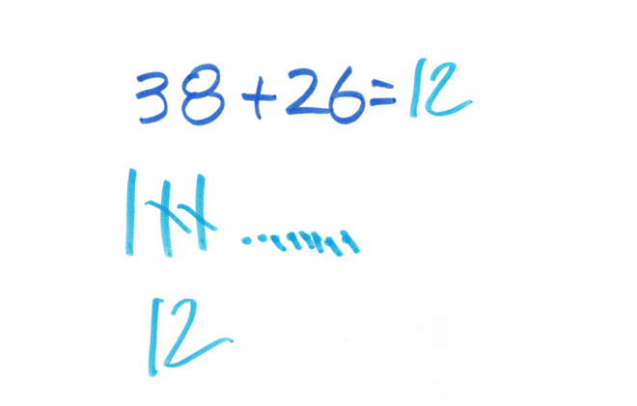 | Access – Notation: Even though she refers to this problem as “adding” she solves it as subtraction. Possible procedural cueing of the double digit subtraction that she has been working on in class.
 | 25:18 K: Great. So how did you figure that out?
 | 25:22 E: I don't know!
Technique: Because she is having difficulty explaining her thinking, I refer back to what she drew as she solved the problem. | 25:22 K: You don't know? What are these lines, meaning? (K points to student's drawing)
 | 25:28 E: These (traces with finger over the crossing out of the dots)
 | 25:29 K: Or even these lines and those dots (points to the ones that are not crossed out).
 | 25:31 E: I'm taking them away. | Access - Quantity: Her explanation focuses on the action (taking away) even when talking about the parts that are not taken away. Note also that taking away is also not aligned with the problem context of addition (38+26=).
 | 25:32 K: Okay, so you're taking them away when you're doing that?
 | 25:35 E: Yeah.
Technique: I clarify to ask about a specific part of the representations she drew | 25:35 K: And so what does this line represent here?
 | 25:39 E: A 10. | Strength: Knows that the line in her drawing represents a ten.
 | 25:39 K: A 10. So are you sort of thinking about these blocks when you're drawing this?
 | 25:44 E: Yeah.
 | 25:44 K: Is that a helpful way of tracking your progress?
 | 25:47 E: Uh huh.
 | 25:47 K: Okay. I'm going to ask one more problem and then we will be done. If you, or maybe what problem do I want to ask? You need to go back any second now, right?
 | 26:15 E: Oh, it's time!
 | 26:16 K: Is it time already? Okay, so then maybe we will just stop there and I will be sad that I don't have more time to hang out with you. Evelyn, thank you so much for doing all of this amazing work!!

