Clinical Interview Question Repository
This question repository is organized by CCSS strand and then by grade level. For any printable images, click on the link and it will take you to a page where you can download and print a handout for that question.
Counting and Cardinality 3
Grade K 3
Operations and Algebraic Thinking 3
Grade K 3
Grade 1 3
Grade 2 4
Grade 3 5
Grade 4 5
Grade 5 5
Grade 6 6
Grade 7 7
Grade 8 7
Functions 8
Number and Operations in Base Ten 10
Grade K 10
Grade 1 10
Grade 2 10
Grade 3 10
Grade 4 11
Grade 5 11
The Number System 11
Grade 6 11
Grade 7 12
Grade 8 13
Number and operations – Fractions à Ratios and Proportional Relationships 13
Grade 3 13
Grade 4 13
Grade 5 14
Ratios/Proportions 14
Grade 6 14
Grade 7 15
Measurement and Data 16
Grade K 16
Grade 1 16
Grade 2 17
Grade 3 17
Grade 4 19
Grade 5 19
Statistics and Probability 20
Grade 6 20
Grade 7 20
Grade 8 21
Geometry 23
Grade K 23
Grade 1 23
Grade 2 23
Grade 3 23
Grade 4 23
Grade 5 23
Grade 6 23
Grade 7 24
Grade 8 26

Counting and Cardinality

Grade K
Know number names and the count sequence. | - Can you show me how you would count starting at 1?  - How high do you think you would be able to go?  - How would you count up starting at 47?  - Can you show me how you count backward from 10?
Count to tell the number of objects. | (Put a number of blocks (15, 9, 12, etc.) in front of the student).  - How would you figure out how many blocks are here?  - How would you write the total?
Compare numbers. | (Put two piles of counters in front of the student).  - How would you figure out which pile has more?  (Write down two numbers between 1 and 10 on a piece of blank paper).  - How would you figure out which number is larger?

Operations and Algebraic Thinking

Grade K
Understand addition as putting together and adding to and understand subtraction as taking apart and taking from. | - How would you solve 1 + 3?  - How would you solve 5 – 2?  - How would you solve this problem:  - Erica had 3 blueberries. Her friend gave her 2 blueberries. How many blueberries does Erica have now?  - How would you solve this problem:  - Marcus had 5 cherries. He ate 4 cherries. How many cherries does he have left?

Grade 1
Represent and solve problems involving addition and subtraction. | - How would you solve this problem:  - Sylvia had 12 colored pencils. She let her brother Jacob have 5 of her colored pencils. How many colored pencils does Sylvia have left?  - How would you solve this problem:  - Dimitry picked 8 small cucumbers and 11 green beans from his garden. How many vegetables did Dimitry pick from his garden?  - How would you solve this problem:  - Quincy lined up his toy cars in a line. He had five red cars, three yellow cars, and four blue cars. How many toy cars did Quincy have in total?  - How would you solve 10 + 4 + 5?
Understand and apply properties of operations and the relationship between addition and subtraction. | (Ask a series of related fact family questions to see if the student uses the previous solution to solve the next problems)  - How would you solve 5 + 7=?  - How would you solve 7 + 5?  - How would you solve 12 - 7=?  - How would you solve 12 - 5?
Add and subtract within 20. | (Decide whether you want to ask the following questions verbally or in written form)  - How would you add 8 + 6?  - How would you solve 13 - 7?
Work with addition and subtraction equations. | - How would you figure out what goes in the blank?  - 4 + ___ = 9  - ___ - 2 = 8  - 11 = ___ + 4  - 5 = __ - 3  - Do you think this equation is right or wrong?  - 4+1=5+2

Grade 2
Represent and solve problems involving addition and subtraction. | - How would you solve this problem:  - Mr. Bennett has 27 kids in his class. Ms. Cline has 25 kids in her class. How many kids are in Mr. Bennett’s and Ms. Cline’s classes?  - How would you solve this problem:  - In the morning there are 58 cookies for sale at the bakery. That day the bakery sells 39 of them. How many cookies are left?  - How would you solve this problem:  - There are 78 second-grade students and 54 kindergarten students at the school. How many more second graders are there than kindergarteners?  - How would you solve this problem:  - There are 82 plants at the nursery. 34 plants are vegetable plants. The rest are flowers. How many plants at the nursery are flowers?
Add and subtract within 20. | - How would you figure out 12 + 7=?  - How would you figure out 20 – 14=?
Work with equal groups of objects to gain foundations for multiplication. | - How would you solve this problem:  - A classroom has 6 rows of desks. There are 4 desks in each row. How many desks are there in total?  - How would you solve this problem:  - There are 8 candies in each pack. If you have 5 packs, how many candies do you have in total?

Grade 3
Represent and solve problems involving multiplication and division. | - How do you think about solving a problem like 5 x 7 = ?  - How do you think about solving a problem like 30 ÷ 6 = ?  - How would you solve this problem:  - Malik rode his bike for 3 miles each day of the week. How many miles did Malik ride his bike after 7 days?  - How would you solve this problem:  - A class of 24 kids were put into 3 groups. How many kids are in each group?
Understand properties of multiplication and the relationship between multiplication and division. | - If you know that 6 x 4 = 24, how would you figure out what goes in the blank space? 2 x ___ x 4 = 24?  - If you know that 13 x 8 = 104, how would you figure out 8 x 13 = ?  - How would you figure out if this statement is true: 12 x 9 = 6 x 18?  - If you know 4 x 8 = 32, does that help you solve 32 ÷ 4? Does it help you solve 32 ÷ 2?
Multiply and divide within 100. | - How do you think about solving a problem like 6 x 8?  - How do you think about solving a problem like 32 ÷ 4?
Solve problems involving the four operations, and identify and explain patterns in arithmetic. | - How would you solve this problem:  - Julia baked 2 batches of chocolate chip cookies. Each batch made 6 large cookies. She sold each cookie for $2.00. How much money did she make after selling all of the cookies?  - How would you solve this problem:  - A bakery baked 48 cupcakes. They sold 36 of them by 2pm. They put the remaining cupcakes into 4 boxes. How many cupcakes fit in each box?

Grade 4
Use the four operations with whole numbers to solve problems. | - How would you solve this problem:  - Andy is baking brownies for a family reunion. He bakes 6 batches with 12 brownies in each batch. He sets aside 8 brownies to share with his friends. He divides the remaining cookies into packaging that holds 4 brownies per package. How many packages of brownies will he have for the family reunion?
Gain familiarity with factors and multiples. | - How would you figure out the factors of 30? 48?  - How would you figure out the multiples for 3? For 7?
Generate and analyze patterns. | - If you saw the sequence 1, 4, 7, 10, 13, 16, 19, 22, how would you figure out what came next?

Grade 5
Write and interpret numerical expressions. | - How would you solve this problem:  - 12 + 3 x 8 – 10  - How would you solve this problem:  - 95 - (6 + 14) x 2³
Analyze patterns and relationships. | - Simone is baking rainbow cookies. She uses 2 cups of flour and 1 cup of sugar for each batch. How would you create a table showing the cups of flour and the cups of sugar for 1, 2, 3, and 4 batches of cookies.  - How would you create two tables to represent the cups of flour and the cups of sugar used?  - How would you graph the cups of flour and the cups of sugar used?  - What relationship do you see between the cups of flour and the cups of sugar used?

Expression and Equations à Functions

Grade 6
Apply and extend previous understandings of arithmetic to algebraic expressions. | - How would you compare n and 4n? Can you tell which is greater, or if they are equal?  - If I tell you that x = 3, what can you tell me about x + 4?
Reason about and solve one-variable equations and inequalities. | - How would you solve  10 = x + 3?  - What does it mean that x = 7?  - If you have the problem 10 = x + 0, how would you figure out what x is?
Represent and analyze quantitative relationships between dependent and independent variables. | - (Give the student a copy of this table)  Two rock climbers are attempting to break the speed record while climbing a popular route in Yosemite. Their goal is to climb 3,000 feet in 110 minutes. They are climbing at a rate of 27 feet per minute. How would you find the missing values in the data table?  - How would you determine the independent and dependent variables?  - (Give graph paper). How would you graph the values on a graph?  - How would you write an equation to represent the climbers’ distance climbed over time?
  Number of Minutes | Number of Feet
  1 | 27
  2 | ?
  ? | 108
  10 | ?
  60 | ?
  100 | ?
  110 | 3,000

Grade 7
Use properties of operations to generate equivalent expressions. | - How would you simplify:  –5(g + 4g – 3g + 7m) - 10m?  - How would you simplify:  $\frac{1}{4}$x(-8 – 16y + 20)?  - How would you factor:  15c + 9c + 18?
Solve real-life and mathematical problems using numerical and algebraic expressions and equations. | - How would you solve 2x + 5 = 17?  - What does it mean that x = 6?

Grade 8
Work with radicals and integer exponents. | - How many equivalent expressions can you write for 2³ * 2² that use exponents or radicals?  - How would you simplify:  - x • x?  - x³ • x²?  - x⁻³ • x²?  - $\sqrt{25}$  - $\sqrt[3]{8}$  - How would you solve:  - (3.25 • 10²) • (2 • 10⁴)?  - (8.4 • 10¹) ÷ (4 • 10⁰)?
Understand the connections between proportional relationships, lines, and linear equations. | - (Give the student a copy of this table)  Two candy bars cost $2.50 and four candy bars cost $5.00. How would you find the missing values in the data table?  - (Give graph paper). How would you graph the values on a graph?  - How would you determine the slope of the line you graphed?  - How would you explain what the slope of this line means?  - How would you write an equation to represent the line you graphed?
  Number of Candy Bars | Cost in Dollars
  1 | ?
  2 | $2.50
  3 | ?
  4 | $5.00
Analyze and solve linear equations and pairs of simultaneous linear equations. | - (Give graph paper). How would you graph these two equations?  $y= \frac{1}{3}$x + 4 and $y= \frac{1}{3}$x - 2  - What do you notice about the lines graphed?  - What do you notice about the solution to this system of equations?  - (Give graph paper). How would you graph these two equations? y = 5 and x = -3  - What do you notice about the lines graphed?  - What do you notice about the solution to this system of equations?  - (Give graph paper). How would you graph these two equations?  y = -2x + 1 and 2x + y = 1  What do you notice about the lines graphed?  - What do you notice about the solution to this system of equations?

Functions
Define, evaluate, and compare functions. | - How would you determine if a function is represented given this mapping diagram? (give student this handout)  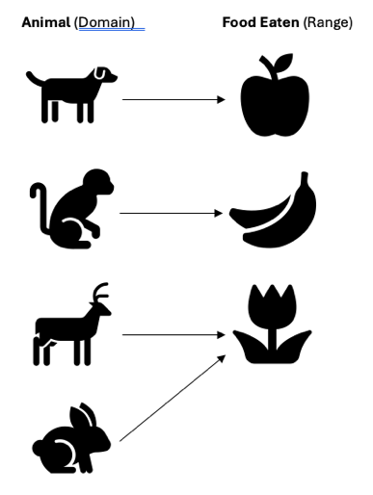  - (Give graph paper). How would you graph the equation x = 4? How would you determine if a function is represented?  - (Give graph paper). How would you graph an equation that represents a function. How do you know a function is represented?  - How would you solve this problem?  - ƒ(x) = -3x – 12; when ƒ(x) = 4  - ƒ(x) = |x + 5|; when x = -15
Use functions to model relationships between quantities. | - (Give the student a copy of this graph)  A hiker starts at an elevation of 460 feet and hikes up a mountain at a steady rate of 1,000 feet per hour. Below is a graph that represents their elevation after 4 hours of hiking.  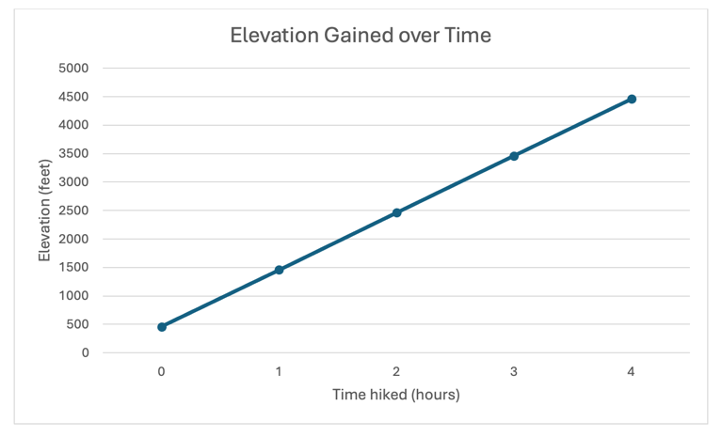  - How would you write an equation to represent the hiker’s elevation as a function of time in hours?

Number and Operations in Base Ten

Grade K
Work with numbers 11–19 to gain foundations for place value. | - If you have 10 blocks (give 10 blocks) and I give you 6 more, how many do you have now? How would you write that down?  - How would you use these blocks (base 10) to show the number 14? How would you write that down? (If they write it correctly). What does the 1 mean? What does the 4 mean?  - How would you write the number you built?

Grade 1
Extend the counting sequence. | - Can you show me how you count up from 86?  - Can you show me how you count by 2s? by 5s?  - Can you show me how you count by 10s? (go past 100)  - Can you show me how you count by 10s starting at 7?  - Can you show me how you count backward by 10s starting at 120?  - Can you show me how you count backwards by 10s starting at 63?
Understand place value. | - How would you make the number 37 with these blocks (base ten blocks)? If you were going to make the number 118, would you count out all ones, or would you make it another way? (ask the student to show you how they would make a given amount – up to 120 – have base ten blocks available)  - How would you write the number you made?
Use place value understanding and properties of operations to add and subtract. | - Can you show me how you would add 34 and 7?  - Can you show me how you would add 62 and 10?  - How would you add 45 + 10?  - How would you subtract 78 – 10?

Grade 2
Understand place value. | - For the number 476 – How would you explain what the 7 means?  - Can you show me how you would make the number 650 using base ten blocks? 843? 1,000?  - How would you write the number you made?
Use place value understanding and properties of operations to add and subtract. | - How would you solve 38 + 26 =  - How would you solve 72 - 35 = ?

Grade 3
Use place value understanding and properties of operations to perform multi-digit arithmetic. | - How would you solve 475 + 168 + 242 =?  - How would you solve 327 – 118 = ?

Grade 4
Generalize place value understanding for multi- digit whole numbers. | - How would you figure out how much larger 50 is than 5?  - How would you read this number aloud?  - Write down various numbers starting with a 2-digit number and see how high the student can go). Note: Fourth grade standard is reading numbers into the millions place.  - How would you compare these numbers (write ###, ###)? Do you know a symbol you could write in between the numbers to show which number is larger or if they are equal?
Use place value understanding and properties of operations to perform multi-digit arithmetic. | - How would you solve the problem 234 – 57 = ?  - How would you solve 436 x 5=?  - How would you solve 24 x 18 = ?  - How would you figure out 275 ÷ 5 = ?

Grade 5
Understand the place value system. | - How would you solve 25 x 10?  - How would you solve 48 x 100?  - How would you solve 350 ÷ 10?  - How would you solve 1.2 x 10?  - How would you determine which number is larger? 3.299 or 3.4? Do you know a symbol you could write in between the numbers to show much number is larger?
Perform operations with multi-digit whole numbers and with decimals to hundredths. | - How would you solve 653 x 24?  - How would you solve 203 x 554?  - How would you solve 3,639 ÷ 3?  - How would you solve 48,240 ÷ 24?  - How would you solve 5.6 x 3?  - How would you solve 3.4 x 2.5?  - How would you solve 1.24 x 6?  - How would you solve 2.34 x 3.5?

The Number System

Grade 6
Apply and extend previous understandings of multiplication and division to divide fractions by fractions. | - How would you solve this problem:  - Addison is making pancakes for breakfast. One batch of pancakes requires one-half cup of buttermilk. She only has her one-fourth measuring cup available to use. How many times will she need to use the one-fourth measuring cup to measure out one-half cup of buttermilk?  - How would you solve ½ ÷ 1/8?  - How would you solve 3/6 ÷ ½?  - How would you solve 2/3 ÷ 1/3?  - How would you solve ¼ ÷ ½?  - How would you solve ¾ ÷ ½?
Compute fluently with multi-digit numbers and find common factors and multiples. | - How would you solve 565 ÷ 2?  - How would you solve 6,428 ÷ 5?  - How would you solve 2.58 x 3.4?  - How would you solve 220 ÷ 2.2?  - How would you find the greatest common factor of 24 and 40?  - How would you find the least common multiple of 4 and 6?
Apply and extend previous understandings of numbers to the system of rational numbers. | - How would you explain the number –3?

Grade 7
Apply and extend previous understandings of operations with fractions to add, subtract, multiply, and divide rational numbers. | - How would you solve  –5 +3?  - How would you solve  –12 + 16?  - How would you solve  –8 + (-3)?  - How would you solve  6 - -4?  - How would you solve  2 – 5?  - How would you solve  -6 - 10?  - How would you solve  2 x (-4)?  - How would you solve  –10 x (-10)?  - How would you solve  –9 ÷ 3?

Grade 8
Know that there are numbers that are not rational, and approximate them by rational numbers. | - How would you determine the square root of 30?

Number and operations – Fractions à Ratios and Proportional Relationships
Fractions

Grade 3
Develop understanding of fractions as numbers. | - How would you think about drawing or writing one half?  - How would you think about drawing a picture of ½? Can you explain your drawing?  - Is there any other way of drawing ½?  - What part of your drawing shows ½?  - How would you think about drawing a picture of 2/3? If someone saw this picture, what would they think it was a drawing of?  - How would you figure out which one is more, or are they equal? (give student drawings)  - If you had the fraction 2/6 and 5/6 which would you say is more, or are they equal?

Grade 4
Extend understanding of fraction equivalence and ordering. | - If you had the fraction 3/4 and 6/8 which would you say is more, or are they equal?  - How would you solve this problem? Are 1/3 and 2/6 equal?  - What fraction would you say is drawn here? (draw an area model of 4/5).  - Someone came and divided it like this (divide the area model in half to create 8/10). Now what fraction would you say is here?
Build fractions from unit fractions by applying and extending previous understandings of operations on whole numbers. | - If this strip of paper was ¾, how would you figure out what ¼ was? How would you figure out what 5/4?  - How would you solve this problem? What would a visual look like that represents the problem?  - Gavin swam ¼ of a mile each day for five days. How many miles did he swim after the five days?  - Gavin increased his distance and swam ¾ of a mile for two days. How many total miles did he swim?
Understand decimal notation for fractions, and compare decimal fractions. | - How would you write 0.45 as a fraction?  - How would you write 3/10 as a decimal?  - How would you solve 5/10 + 2/100?  - How would you determine which decimal is larger? Or are they equal?  - 0.4 and 0.04  - 0.80 and 0.8

Grade 5
Use equivalent fractions as a strategy to add and subtract fractions. | - How would you solve ½ + ¼?  - How would you solve 2/3 + 1/6?  - How would you solve  3 – 5/4?  - How would you solve  2 1/2 - 1 1/3?
Apply and extend previous understandings of multiplication and division to multiply and divide fractions. | - How would you solve this problem?  - After a school pizza party there are 7 pizzas with ¼ of the pizza left. How much pizza is remaining?  - There is 1/2 of a birthday cake left in the refrigerator. If you eat 1/3 of the cake that is left, what fraction of the cake is now left?  - Half a pan of brownies is shared between 4 friends. How much does each person get?  - How would you solve?  - ¼ ÷ 1/8  - 2/3 x 6/7  - 2 ½ ÷ ¼  - 2 ½ x 1/3

Ratios/Proportions

Grade 6
Understand ratio concepts and use ratio reasoning to solve problems. | - If the ratio of humans to pets in my house is 2:3, and there are 6 family members, how would you figure out how many pets there are in the house?  - An apple cake recipe uses a ratio of 4 large eggs to 1.5 cups of sugar. If someone only has 2 large eggs, how much sugar should they use to maintain the same sweetness?  - How would you solve?  - 50% of $30.00  - 10% of $30.00  - 1% of $30.00  - 20% of $30.00  - 25% of $30.00  - 70% of $30.00

Grade 7
Analyze proportional relationships and use them to solve real-world and mathematical problems. | - How would you solve the problem?  - Kamari paid $60.00 for a haircut. If she tipped her hairstylist 20%, how much did she pay for her haircut?  - Danny jogged for 12 minutes on Monday and 15 minutes on Wednesday. What was his percentage increase from Monday to Wednesday?  - (Give the student a copy of the table below).  - How would you determine the unit rate given this data table?  - How would you figure out the y coordinate if the x coordinate is 1?  - How would you write an equation to represent the values in the data table.
  Number of Wetsuits Sold | Cost in Dollars
  3 | $750.00
  5 | $1,250.00
  6 | $1,500.00
  10 | $2,500.00

Measurement and Data

Grade K
Describe and compare measurable attributes. | - (Give the student 2 objects). How would you compare the length of each object? How would you compare the weight of the objects?
Classify objects and count the number of objects in categories. | - (Give the student various objects that can be sorted into categories. Examples – cars, action figures, writing utensils, books, etc.).  - How would you sort these objects into different groups?  - Which group has the most objects?  - Which group has the least objects?  - Are there any groups with the same number of objects?

Grade 1
Measure lengths indirectly and by iterating length units. | - (Give the student 3 objects to measure and compare the length of to each other. Examples of objects to use – pencils, pens, colored pencils, crayons, books, etc.).  - How would you figure out which object is the shortest in length? The longest in length?  - How would you use unifix cubes (or other tool) to measure this desk (or other object)? How long is (object)? How did you figure out the length of (object)?
Tell and write time. | - Set an analog clock to a time that is on the hour – for example, 2:00  - How would you read the time on this clock?  - How would you read this time (write 6:00)?  - How would you make this clock show 8:00?  - How would you read this time aloud (write 7:30)?  - Set an analog clock to a time that is on the half hour – for example, 4:30  - How would you read the time on this clock? How did you figure that out?
Represent and interpret data. | - Show the student a picture of this pictograph – Titled: Which dessert do you like the best? Cookies, ice cream, or donuts?  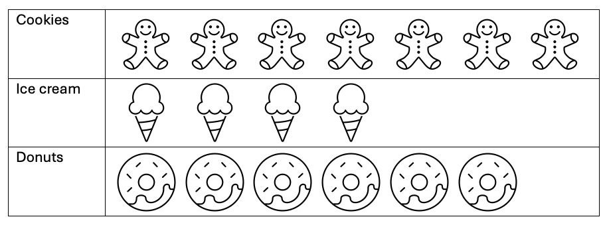  - How would you determine which dessert is the most popular? How many students chose that dessert?  - How would you determine which dessert is the least popular? How many students chose that dessert?  - How would you find how many more kids chose donuts than ice cream?  - How would you determine how many students participated in this survey?

Grade 2
Measure and estimate lengths in standard units. | - (Give the student a pencil). About how many inches long would you say this pencil is?  - If I drew this number line (put 0 and 4), where do you think 6 would go? (handout)  - 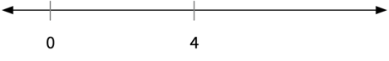
Relate addition and subtraction to length. | - How would you solve this problem?  - Nathan’s plant was 14 inches. It grew 24 inches more. How tall is it now?  - Joey ran 8 miles, he then ran 5 miles more. How would you figure out how many miles he ran total?
Work with time and money. | - How would you read this time aloud (write 10:05)?  - Set an analog clock to a time that is in a 5-minute interval – for example, 3:15  - How would you read the time on this clock? How did you figure that out?  - How long would it be before it was 5:00?
Represent and interpret data. | - (Give the student a copy of this histogram). How would you figure out:  - What pet is most popular?  - How many kids like that pet?  - How would you figure out how many more kids like horses than parrots?  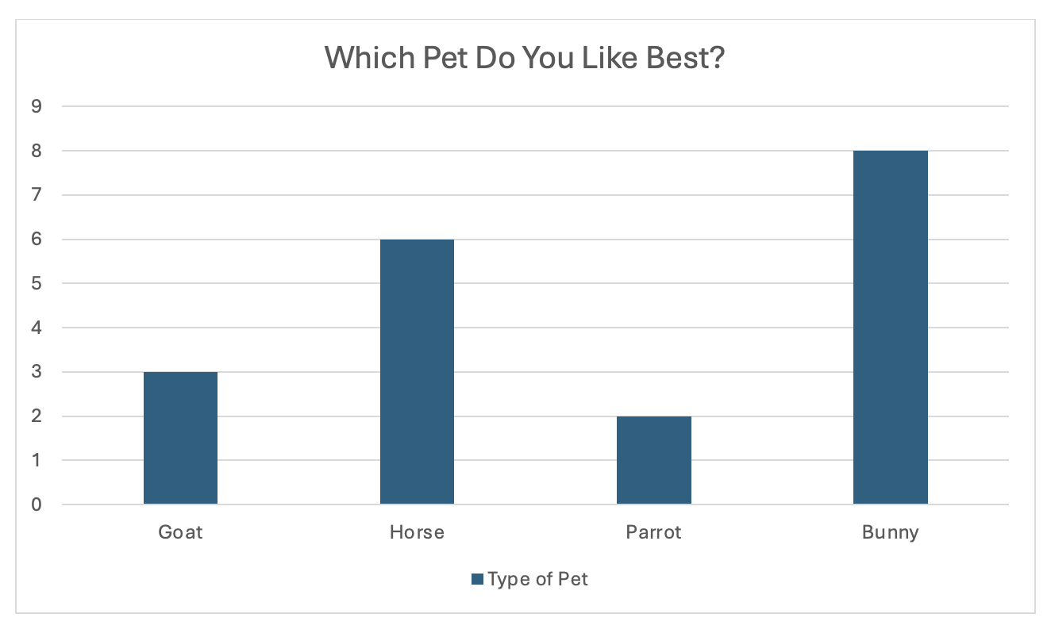

Grade 3
Solve problems involving measurement and estimation of intervals of time, liquid volumes, and masses of objects. | - Set an analog clock to a time that is in a 1-minute interval – for example, 9:03  - How would you read the time on this clock? How did you figure that out?  - Give the student an analog clock and ask them to show you a given time - for example, 1:52  - How would you make this clock display the time 1:52?  - Derek started watching a movie at 6:45 pm. The movie ended at 8:15 pm.  - How would you figure out how long Derek was watching the movie?  - Set an analog clock to 3:40.  - How would you figure out how long until it is 5:00?
Represent and interpret data. | - (Give the student graph paper to create a bar graph and the handout with the following question and data)  How do you travel to school in the morning? Data was: 4 kids walk, 12 kids ride the bus, 3 kids ride their bike, and 7 kids are driven.  - How would you determine the best scale (number to count by) for the graph?  - How would you find how many more kids ride the bus than are driven to school?  - How would you find how many more kids ride the bus than walk or ride their bikes?  - How would you find how many kids took this survey?
Geometric measurement: understand concepts of area and relate area to multiplication and to addition. | - If this were your garden (give the student this picture) and each square was a square foot. How would you figure out the perimeter? How would you figure out the area?  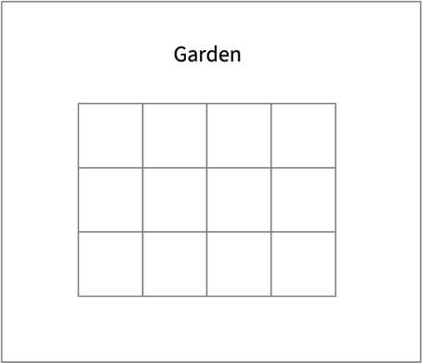
Geometric measurement: recognize perimeter as an attribute of plane figures and distinguish between linear and area measures. | - If this were your flower garden (give the student this garden) and each square was a square foot, how would you figure out the perimeter?  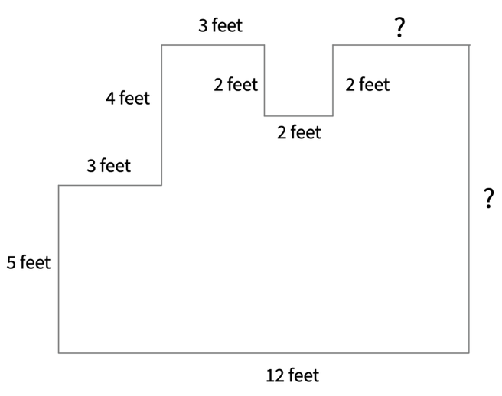

Grade 4
Solve problems involving measurement and conversion of measurements from a larger unit to a smaller unit. | - How would you figure out how many seconds are in 4 minutes?  - How would you figure out how many centimeters are in 3 meters?  - How would you figure out how many grams are in 5 kilograms?
Represent and interpret data. | - Emir baked a dozen sugar cookies for a bake sale. He wanted to check the thickness of each cookie, so he measured the thickness with a ruler. He got these data (give student this handout) in inches.  - $\frac{1}{8} , \frac{1}{2}$ , $\frac{1}{2}$ , $\frac{1}{4}$ , $\frac{1}{2}$ , $\frac{1}{4}$ , $\frac{1}{8} , \frac{1}{8}$ , $\frac{1}{4}$ , $\frac{1}{4}$ ,  $\frac{1}{4}$ , $\frac{1}{4}$  - Make a line plot to represent the cookie thicknesses.  - What is the difference between the thickest and thinnest cookie?
Geometric measurement: understand concepts of angle and measure angles. | - (Draw an angle on a blank piece of paper and have a protractor available for the student to use)  - How would you determine how many degrees this angle measures?

Grade 5
Convert like measurement units within a given measurement system. | - Nolan was planning a rock-climbing trip and wanted to ensure he brought enough rope. The route he is climbing is about 40 meters high. If his rope is 6,000 centimeters long, does he have enough rope to climb the route?  - How would you solve this problem if you knew there are 100 centimeters 1 meter?
Represent and interpret data. | - Himari is training for a local 5K race. She recorded the miles she ran each day while training for the race. (give student this handout)  - 2, 1$\frac{1}{2}$ ,1 $\frac{3}{4}$ , 2$\frac{1}{2}$ , 2$\frac{1}{2}$ , 3, 1 $\frac{3}{4}$  - Make a line plot to represent the miles she ran.  - How many total miles did Himari run after the seven days of training?
Geometric measurement: understand concepts of volume and relate volume to multiplication and to addition. | - (Give the student this picture).  - How would you determine the volume of this right rectangular prism?  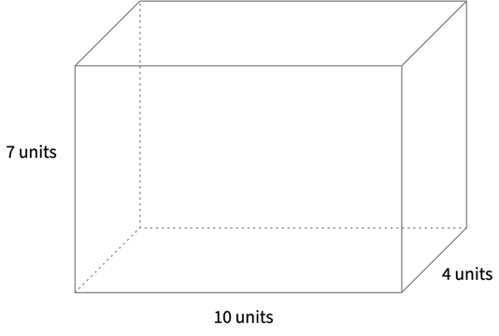

Statistics and Probability

Grade 6
Develop understanding of statistical variability. | - How would you evaluate which of these questions would lead to gathering better survey data? Explain your choice.  - What is your favorite sport to play in the summer? OR Did the girls’ basketball coach play sports over the summer?
Summarize and describe distributions. | - How would you create a dot plot for the data collected?  - The number of pets each student had in a fifth- grade classroom:  - 3,2,0,2,1,4,0,2,0,5,1,3,2,4,0,1,3,2,5,3,1,2,0,3,1  - How would you determine how many students responded to the survey question?  - How would you determine the mean/average of the data? What does the mean/average tell you?

Grade 7
Use random sampling to draw inferences about a population. | - If you sampled all the students in your math class and asked what their favorite pizza topping was, would you think that would be a good estimate of all people in the country?
Draw informal comparative inferences about two populations. | - A softball coach records the pitching speed of two pitchers on her team. (Give student this handout)  - Pitcher 1: 50, 54, 50, 55, 52, 60  - Pitcher 2: 54, 52, 65, 60, 54, 51  - How would you calculate the mean throwing speed of each pitcher?  - How would you determine which pitcher throws at a faster rate?  - How would you calculate the mean absolute deviation for each pitcher?
Investigate chance processes and develop, use, and evaluate probability models. | - How would you explain what the word probability means?  - (Give the student a 6-sided die)  - If you roll this die once, how would you determine the probability that it will land on a 5?  - If you roll this die once, how would you determine the probability that it will land on an even number? An odd number?  - If you roll this die once, how would you determine the probability that it will land on the number 7?  - If you roll a 2, is it more likely your next roll would be a 5 or another 2?  - (Give the student a 6-sided die and a penny)  - If you roll this die once and flip this coin at the same time, what is the probability that you will land on a 4 and heads?

Grade 8
Investigate patterns of association in bivariate data. | - (Give the student a copy of the graph below)  A college hockey coach recorded the number of hours his forwards practiced for a week and the percentage of goals they scored.  - How would you describe the pattern of association?  - If you were to draw a straight line, how would you know if it best fits the data?  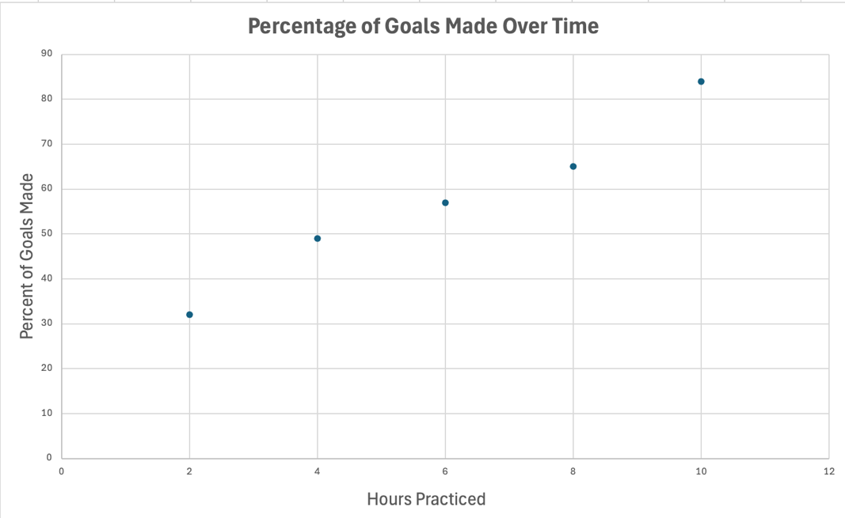

Geometry

Grade K
Identify and describe shapes. | - How would you draw a triangle/rectangle? How do you know it is a triangle/rectangle?
Analyze, compare, create, and compose shapes. | - (Have pattern blocks of different shapes and sizes available)  - Choose 2 shapes to compare. How are the 2 shapes different? What makes the 2 shapes different? How are the 2 shapes similar? What makes them similar?

Grade 1
Reason with shapes and their attributes. | - How would you draw a square/rectangle? How do you know it is a square/rectangle?

Grade 2
Reason with shapes and their attributes. | - How would you draw a triangle/rectangle? How do you know it is a triangle/rectangle?  - (Give the student an image of a cube)  - What would you call this shape?

Grade 3
Reason with shapes and their attributes. | - How would you draw a rhombus/rectangle? How do you know it is a rhombus/rectangle?

Grade 4
Draw and identify lines and angles, and classify shapes by properties of their lines and angles. | - How would you draw an angle that was 90 degrees? 180 degrees?  - How would you draw parallel lines?  - How would you draw perpendicular lines?

Grade 5
Graph points on the coordinate plane to solve real-world and mathematical problems. | - If you have the coordinates (3,4), how would you plot that point (give graph paper with axes)?  - If you saw this point (put a dot at (5,3), can you figure out how to write the coordinates?
Classify two-dimensional figures into categories based on their properties. | - (Give student a set of shapes cut out,) How would you group these shapes?

Grade 6
Solve real-world and mathematical problems involving area, surface area, and volume. | - How would you determine the area of this right triangle?  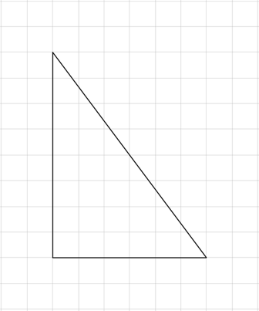  - How would you determine the area of this parallelogram?  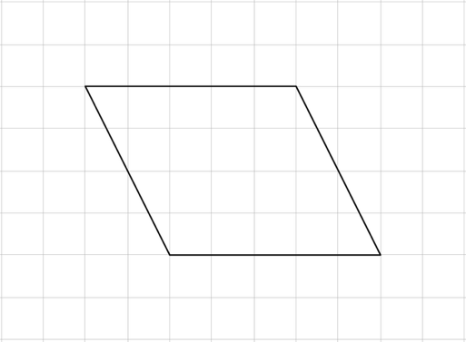  - (Give the student graph paper). How would you create a graph and graph these ordered pairs?  - (2,2), (-2,2), (2,-3), and (-2,-3)  - If you connect the points, what polygon is made? How do you know?  - How would you determine the area of the polygon?  - How would you determine the surface area given this net of a square pyramid?  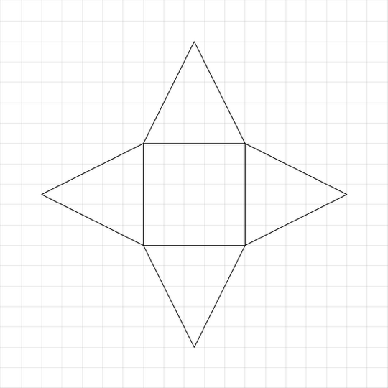

Grade 7
Draw, construct and describe geometrical figures and describe the relationships between them. | - (Give the student graph paper). How would you enlarge this rectangle using a scale factor 1:4?  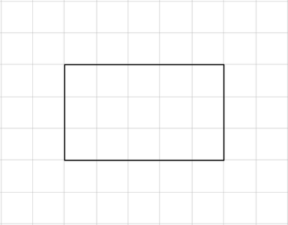  - (Give the student graph paper). How would you reduce this triangle using a scale factor 3:1?  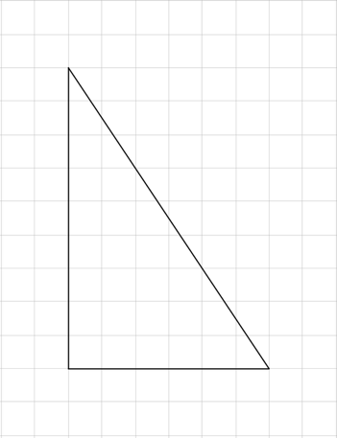  - (Have a ruler and protractor available). How would you construct an acute equilateral triangle?  - (Have a ruler and protractor available). How would you construct a triangle with the following angle measurements: 45°, 100°, and 90°?
Solve real-life and mathematical problems involving angle measure, area, surface area, and volume. | - How would you describe what the circumference of a circle represents?  - How would you describe what the symbol $π$ represents? How is it related to circles?  - How would you describe what the radius of a circle represents?  - How would you describe what the diameter of a circle represents?  - How would you find the  circumference of a circle if the radius is 5 inches and the formula for the circumference is C = $π$d or C = 2$π$r?  - How would you find the area of a circle if the radius is 5 inches and the formula for the area of a circle is: A = $πr^{2}$?  - How would you describe complementary angles? How would you find the missing complementary angle in this picture?  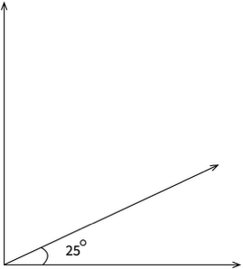  - How would you describe supplementary angles?  - How would you find the missing supplementary angle in this picture?  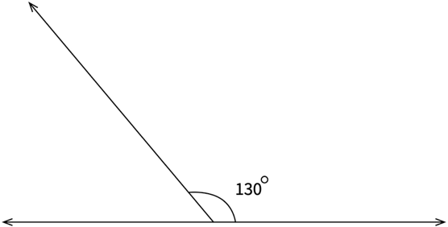  - How would you solve for x in this problem?  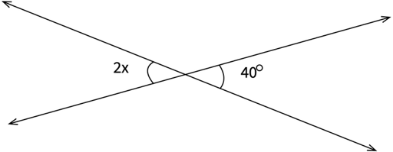  - How would you solve for x in this problem?  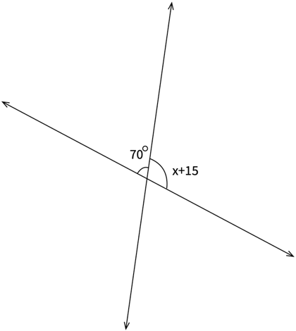

Grade 8
Understand congruence and similarity using physical models, transparencies, or geometry software. | - (Give the student graph paper) How would you graph the following ordered pairs?  - (2,1), (2,5), and (6,1)  - Connect the points to make a right triangle  - How would you reflect the right triangle over the y-axis?  - What are the ordered pairs of the second right triangle?
Understand and apply the Pythagorean theorem. | - How would you describe the Pythagorean Theorem?  - How would you describe the hypotenuse of a right triangle?
Solve real-world and mathematical problems involving volume of cylinders, cones and spheres. | - How would you classify this shape?  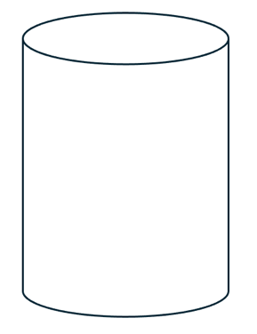  - How would you find the volume of this solid if you knew the formula was as follows: V = $πr^{2}h$ ?  