Draw a picture of $\frac{1}{2}$

Draw another way to show $\frac{1}{2}$

Draw a picture of $\frac{3}{5}$

Draw a picture of 1 $\frac{5}{8}$

Circle all the pictures you think are the same thing as $\frac{1}{2}$

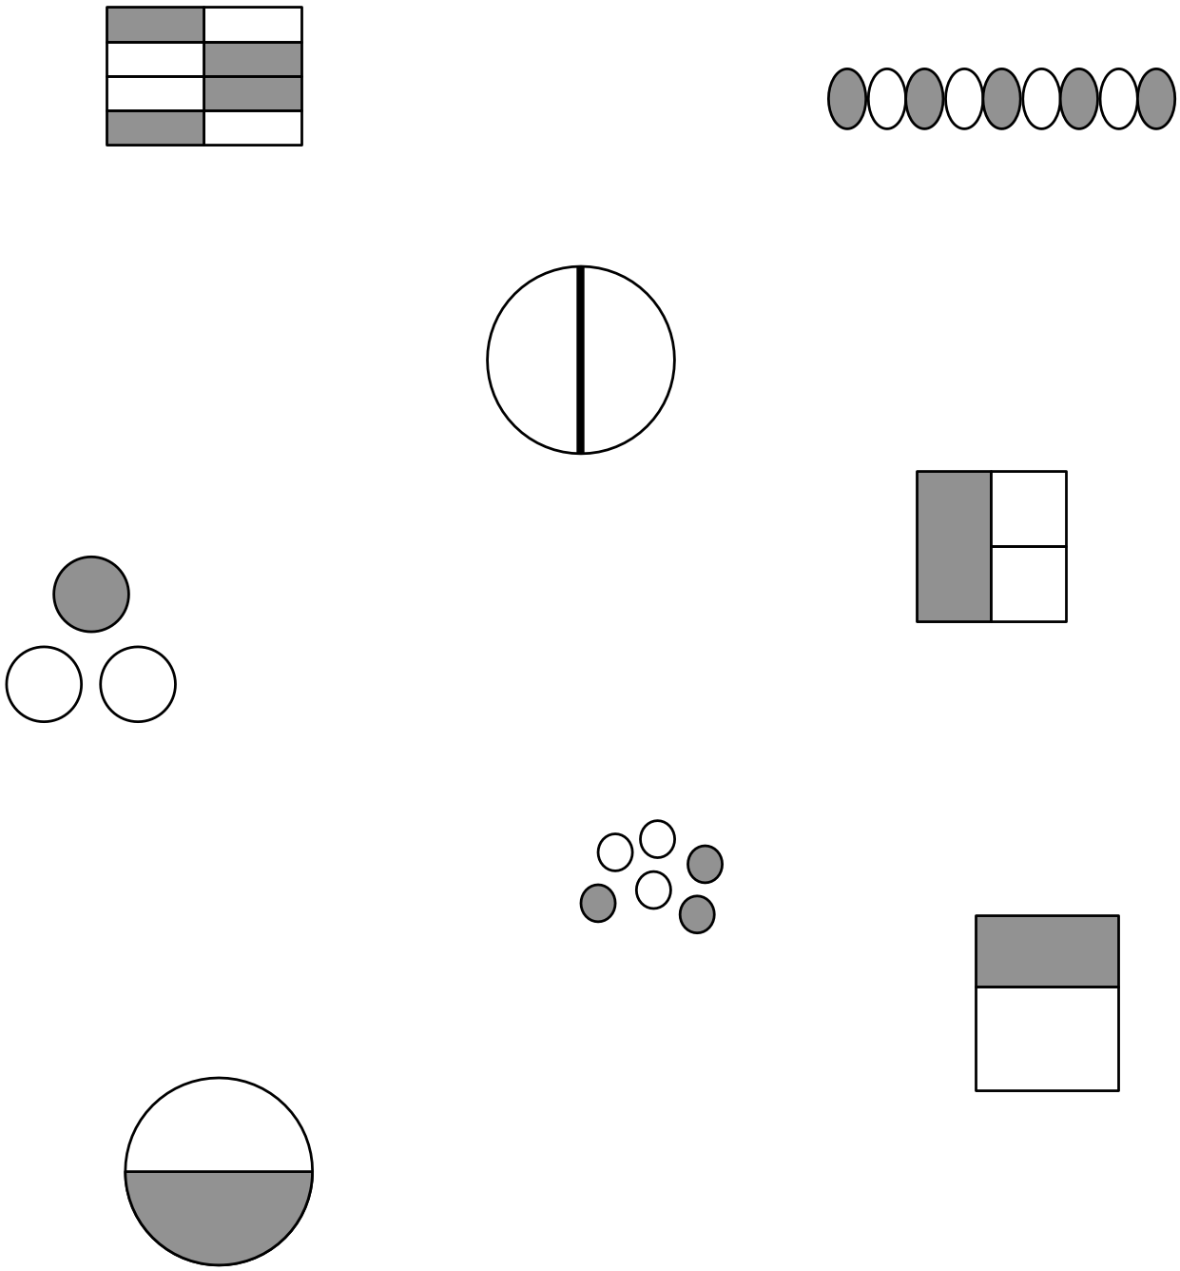

Which is more $\frac{1}{6}$ or $\frac{1}{8}$ ? ________ (you can draw pictures to help you)

Explain your answer:

___________________________

___________________________

___________________________

___________________________

___________________________

___________________________

Which is more $\frac{2}{8}$ or $\frac{5}{8}$ ? ________ (you can draw pictures to help you)

Explain your answer:

___________________________

___________________________

___________________________

___________________________

___________________________

___________________________
Lisa drew this picture. Then Lisa cut it in half like this.
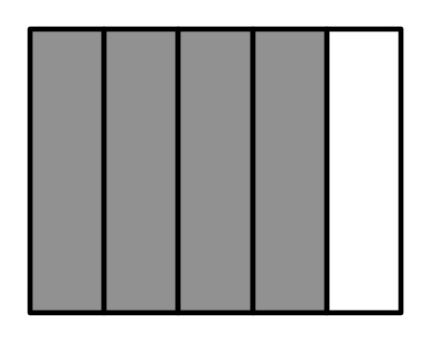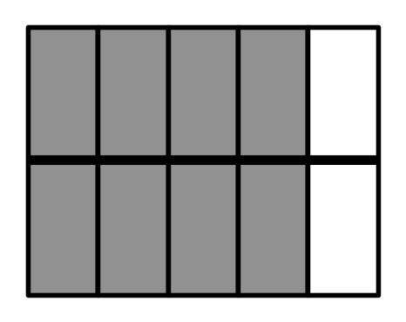

What fraction did she draw? What fraction does this
drawing show now?

_________ ____________

Which is bigger? (circle your answer)

Explain your answer:

___________________________

___________________________

___________________________

___________________________

(A) (B)

(C) They are equal

Explain your answer:

___________________________

___________________________

___________________________

___________________________

(A) (B)

(C) They are equal
Solve the problem $\frac{1}{2}+\frac{1}{4}$ = using pictures.

Answer: ____________

What fraction does the picture show? _____________

